Visual Studio 2019 Tutorial (C# Windows)

1. Start Visual Studio 2019

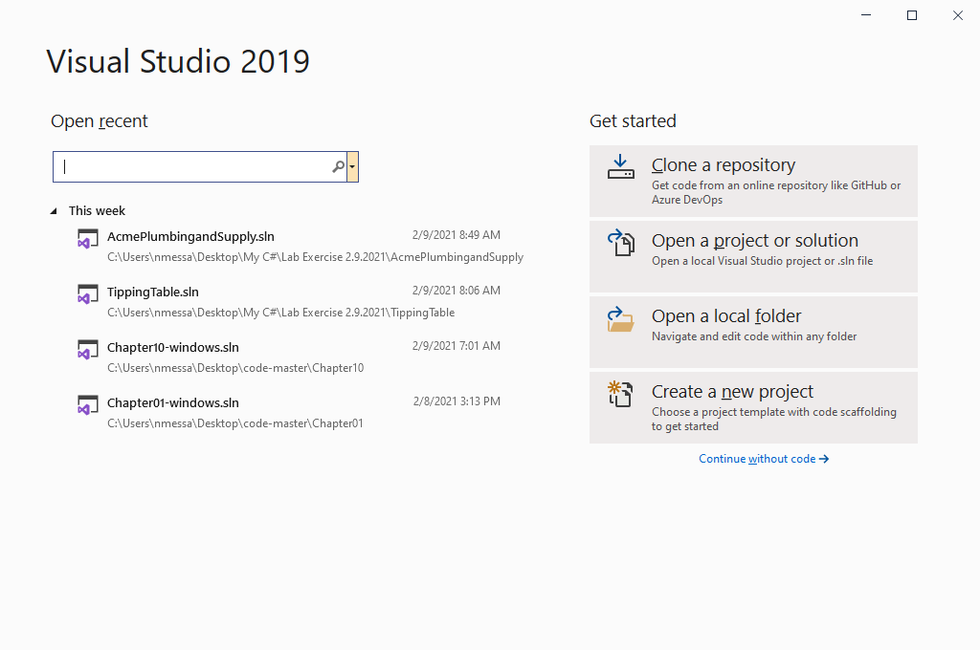

1. Click on Create a new project. Make sure C# Windows Desktop is chosen, select Windows Form App (.NET Framework) and click Next.

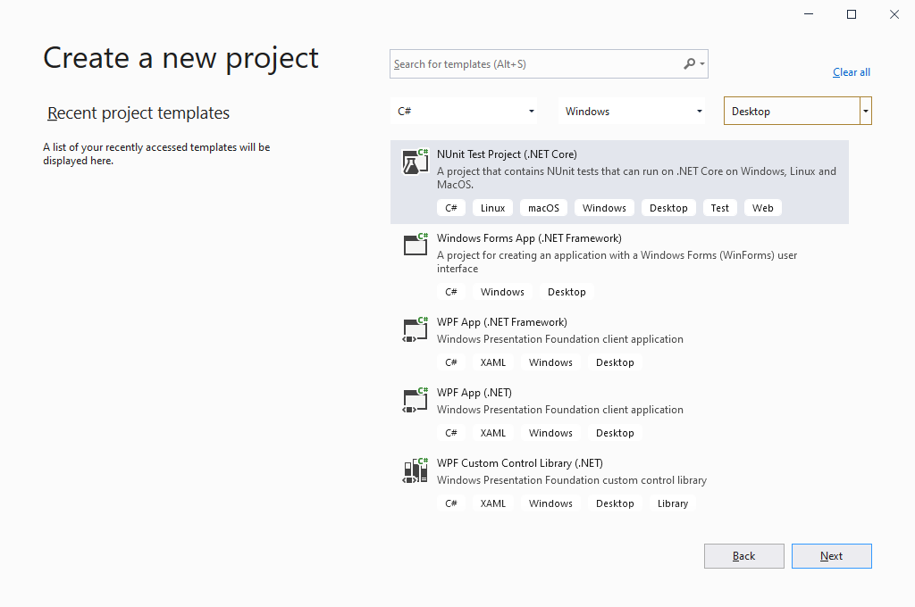

1. Set the Project name and Location. I called my project Hello World and set the location to the MyC# folder on my desktop. Click Create.

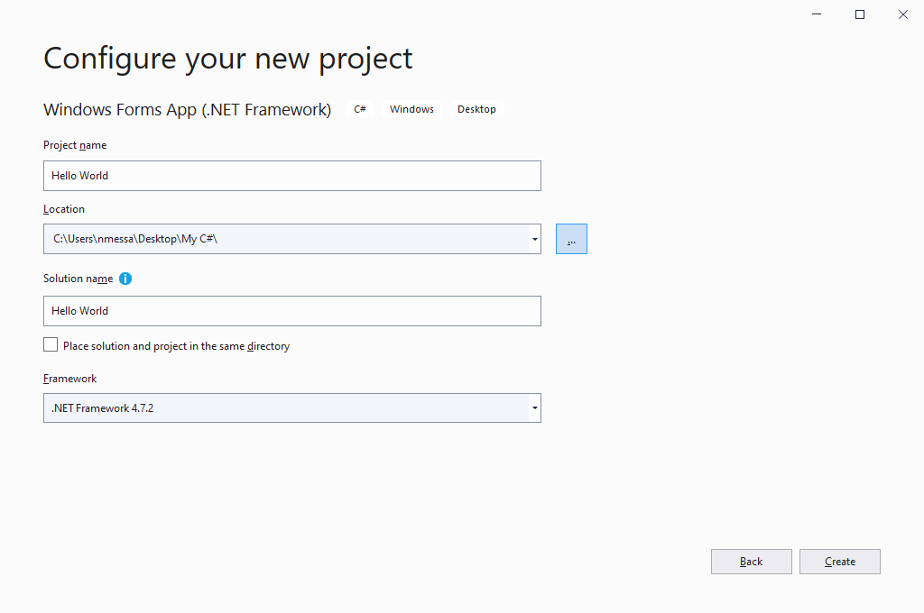

1. Your project should look like this.

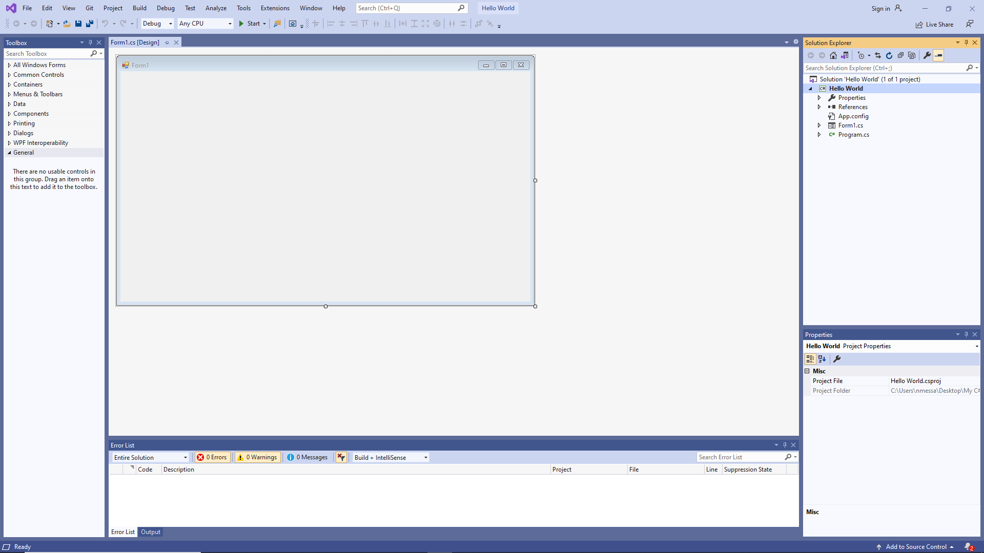

Notice the Toolbox is on the left with the Solution Explorer and Properties Window on the right. The can be placed in Auto Hide mode.

1. Open the Common Controls in the toolbox.

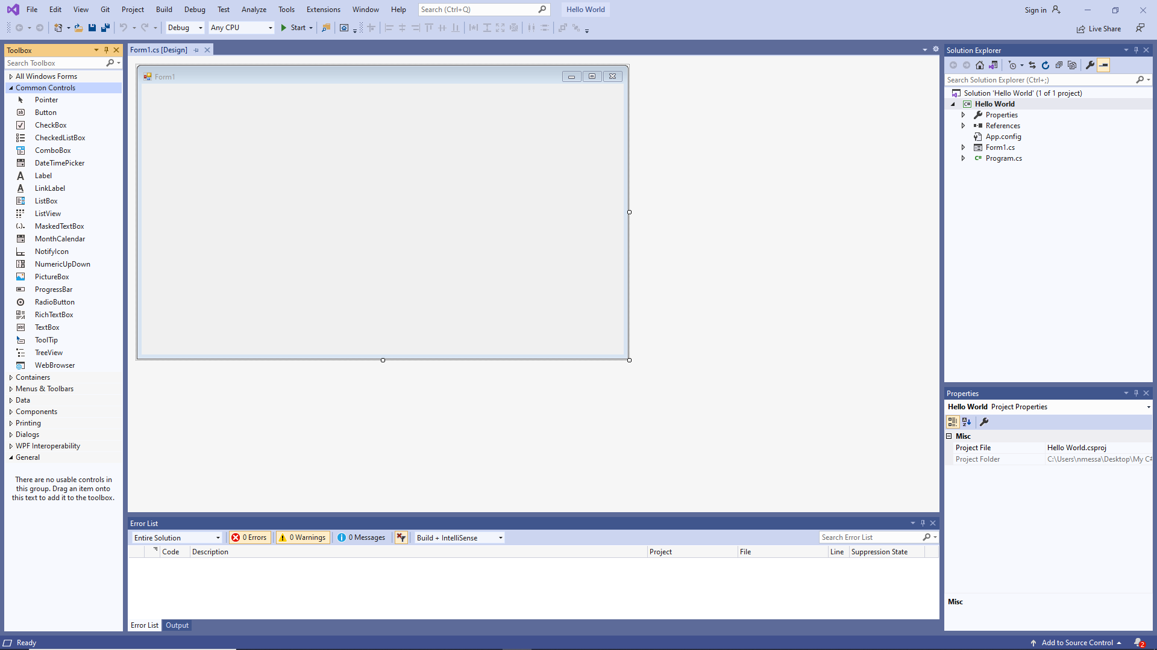

1. Drag a Button and Label to the Form.

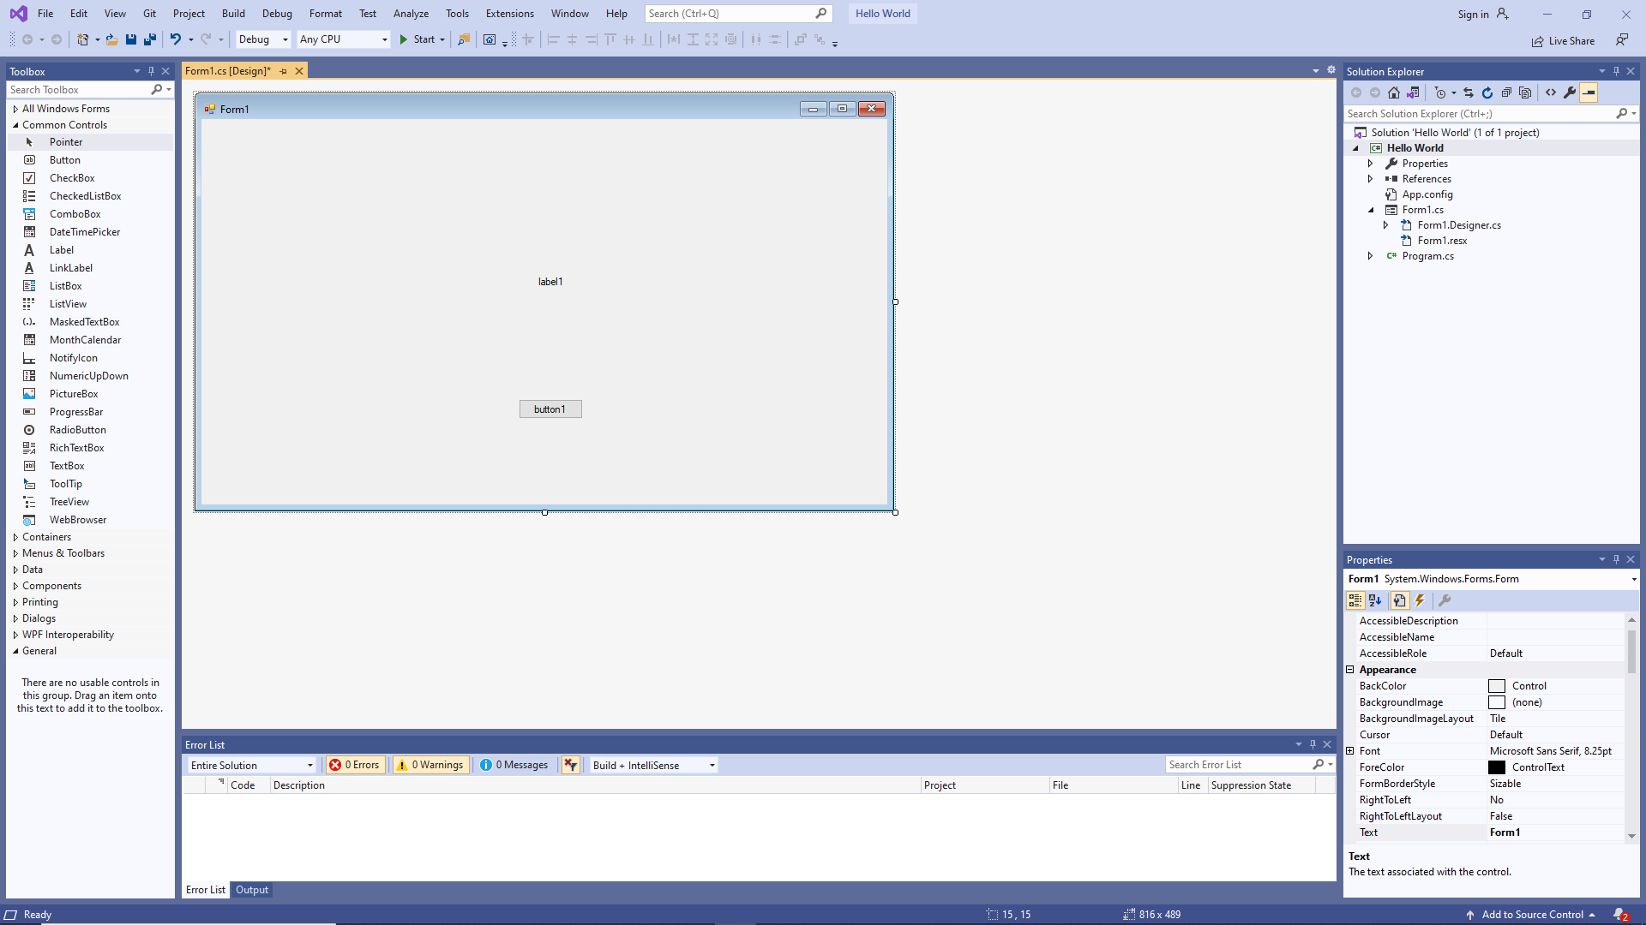

1. Change the Name and Text properties of the Button to btnHello and Greeting respectively.
2. Change the Name and Font properties to lblHello and 20 point respectively.

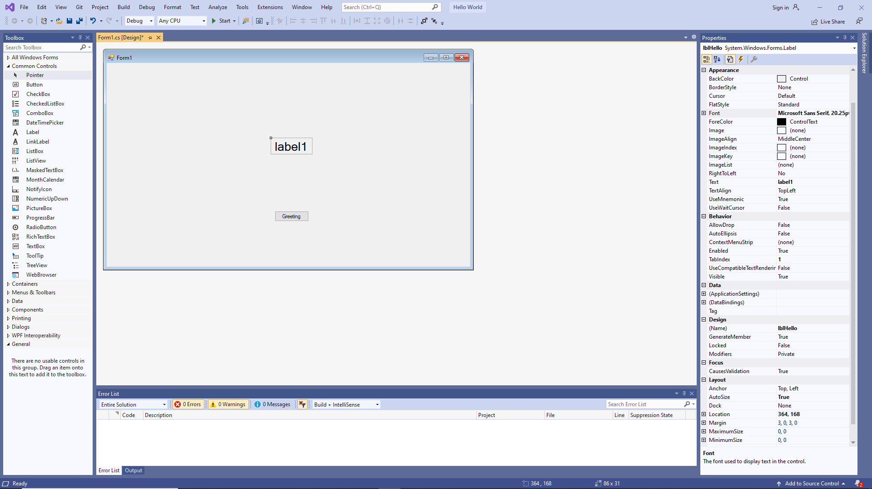

1. Double-click on the Button and it will open the Form code window and generate a skeleton for the btnHello_Click event handler.

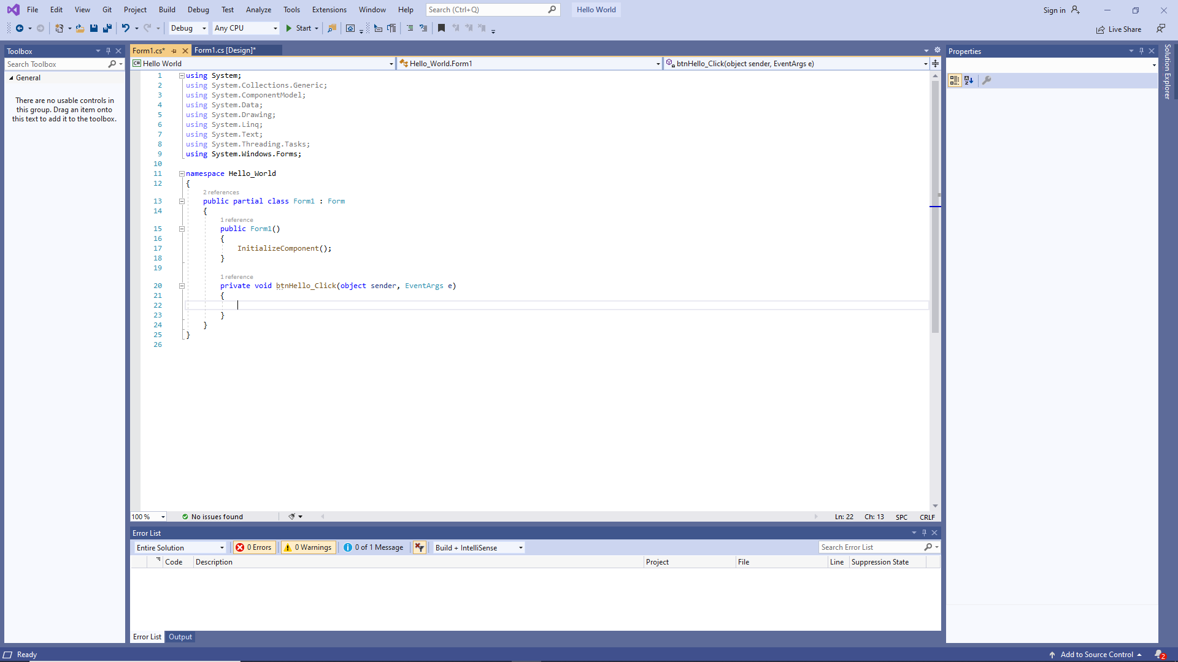

1. Add the following code to the btnHello_Click event handler.

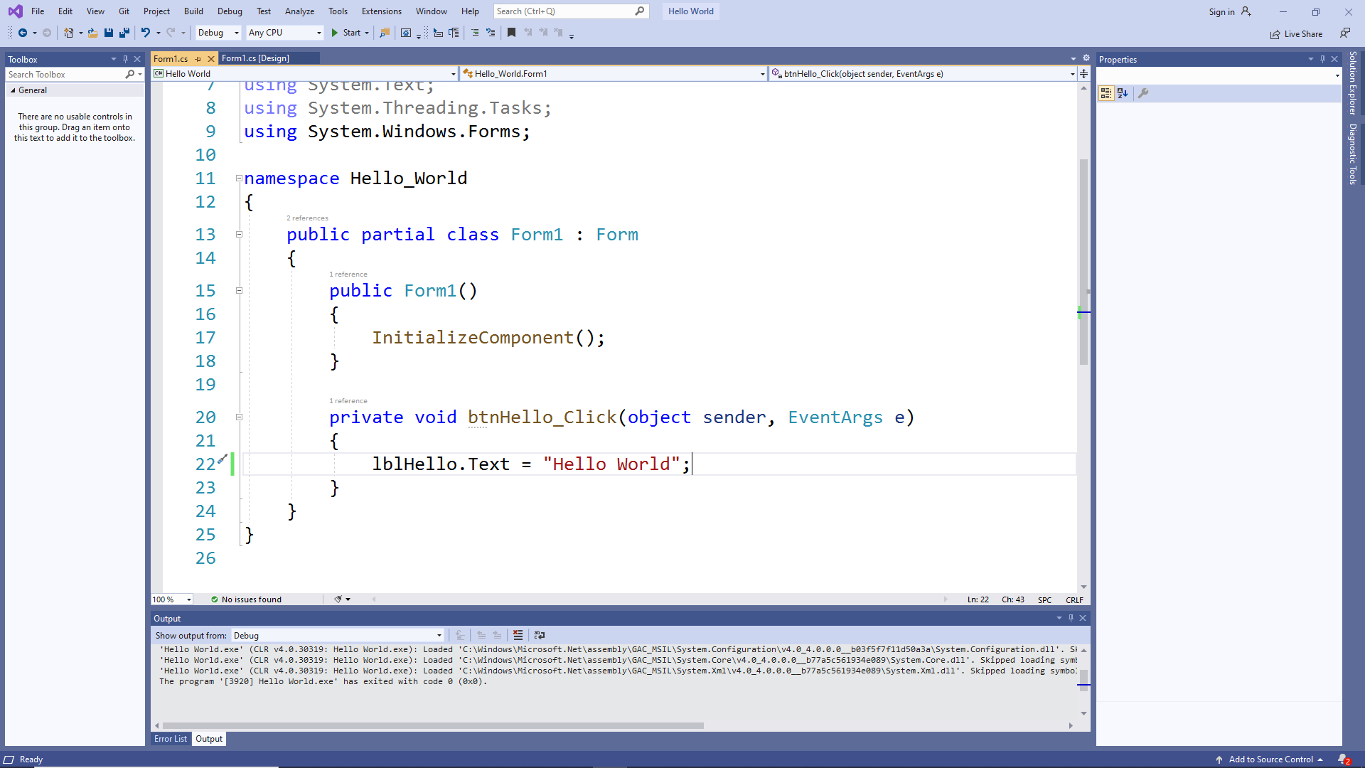

1. Click the Start button to run you program. When you click on the Greeting button on you form the label text should change to “Hello World”.